# Abstract

The current project aims to simulate the effect of Light Painting, which is actually a photography technique more than painting itself, with the aid of Microsoft Kinect. The aim was to resemble as best as possible features that can be met during photo capture, and imitate the effects of capturing light during long exposure settings. The project was developed in the Processing environment and was evaluated by observing and interviewing users. Their comments and suggestions were adopted to create an improved version of the application and were presented at the final seminar of the course DT2140 Multimodal Interaction and Interfaces. More advanced features are also presented in this report and are suggested for future development.

# 

# 

# Table of Contents

Abstract

Table of Contents

Introduction

Application Design

Interaction Design

Hardware and Software Setup

Application Specification

Technical Development

Working with Kinect

Evaluation

Final Version

Conclusion

References

Appendix

Appendix A: Operational flow diagram

Appendix B: Project Plan from Project Proposal

Appendix C: Project Plan Timeline

# 

# 

# Introduction

This project aims to simulate the effect of light painting in a photo capture using Microsoft Kinect. Light Painting is a photography technique that uses slow shutter speed [2] for long exposure and a light source that works as a “brush on the photographic canvas”. Because of the length of the exposure, the light that is captured from the source retains a continuous trail on the final result (unless the source is switched off). The present application replaces the light source with the user’s hand, and the camera with a Kinect and a monitor. For its implementation, the environment of Processing [22] is used with its own and third party libraries.

Developing an application for the Kinect was a valuable opportunity for the group to experiment on state-of-the-art technology that can be used in various installations. Initially, driven by the implementations of sign language with the Kinect [30], we wanted to develop a similar project, thus exploring the possibilities of Kinect and contributing to the social whole. However, a more careful consideration indicated that it was not the right project to initiate us into working with Kinect. After more brainstorming sessions, the team decided to focus on the field of entertainment and develop an application that would encourage creativity and increase awareness of photography techniques.

Light painting [7] is a photographic technique that uses long exposure to capture the movement of a light source. It can be done either by moving the light source, as mentioned, or by moving the camera (also known as camera painting).

The idea was to replicate the results of photography on a setup, where the Kinect and a user’s hand would replace the camera and the light source, respectively. In order to implement this, a study on multimodal interfaces needed to be performed beforehand and decide which modalities would be adopted by the application. The Kinect offers gesture-based as well as speech recognition, which comes more natural for the user [8]. It is a motion-sensing input device built by Microsoft [14], which helps the users to intuitively interact using gestures. Kinect contains three main hardware units [6]:

* RGB camera - Aids in detecting features, such as facial recognition, by detecting the Red, Blue and Green color components
* Depth sensor (infrared emitter and sensor) - Helps in detecting the depth of an object in front of Kinect
* Multi-array microphone - Used in voice control. Also, it has the ability to isolate the voices of the users (maximum 4) from the noise in the room.

In order to get started with programming for Kinect, there is a Kinect programming guidebook [5] for us to take reference from, which includes basic knowledge and tutorials to guide beginners to start programming in Processing for Kinect.

Before getting to the implementation phase, it was essential to look for relevant projects or studies. A similar study has been conducted with the Intangible Canvas Project [17], a digitally projected finger painting application which employs ZeroTouch picture frame as a painting canvas and iPad as a colour palette. This study gave us also valuable insight on evaluation methods of similar installations. Besides, there are also some other projects which are related to painting that we have taken reference of [13, 18, 28], they all make use of gesture-based interaction using interfaces in different modalities, e.g. mobile phone as a spray, physical props like painting brush and buckets with tracked sensors to be used inside a designed cave, and also a wand-like stick inside a virtual environment. To be even more similar to what we would do, there are some other interesting painting projects done by people using Kinect. One of them is a fascinating project which has been realised by Jean-Christophe Naour, the Kinect Graffiti [19]; a neon-light representation of body motion when creating graffiti art. The most relative project that surfaced was a drawing application that uses neon-light effects as a brush and uses Kinect gesture input for the sketch [15].

# Application Design

In our application, light painting with Kinect, we made an effort to simulate the effects of light painting as close to the real light painting as possible. Our application replaced the light source (such as a torch) with the user’s hand and the camera by Kinect. The simulation and effects produced by real camera during light painting were developed in Processing.

The core feature of the application is a painting canvas which allows users to use their hand movement to navigate the light source freely around the canvas. Unlike general drawing canvas using a normal brush, the light source would leave trails on the canvas when it moves around. The size of the trail changes according to the speed of movement (just like in actual light painting), so that the trail will become thinner when the movement is faster and thicker when the movement is slower.

It is very common in light painting, to mix the real environment with the light source. The camera does not only capture the light but also the environment, like the usual way we take a photo, but with special light effect added on top. Many dramatic effects can be added in a photo like this, e.g, a person with light glowing wings, a bicycle with glowing fire, etc. Therefore, in our design, instead of painting on a blank canvas, we also shows the live video feed of the user’s context in the same painting canvas to give user a feeling that “they are being captured by a camera”. The video live feed on the canvas is made possible by turning on the Kinect RGB camera, capturing a frame in the video and do drawing on top of that one, instead of a blank canvas.

## Interaction Design

The application employs gesture-based interaction as the basic input method. Users use their hand gestures to paint freely on the air exactly like the way people do light painting in the real world, while the only difference being that the result would be recorded and displayed on the monitor screen. We provide users a physical way to control and interact with the digital information presented as virtual objects, which according to Jennifer Golbeck’s definition (2002), suggests direct manipulation [11].

When we were designing the user interface of our application, we decided that the first page of the application should already have the painting feature readily available to the users so that users would be attracted by the application even they are just passing by the device unintentionally. Therefore, the starting-up requirement (or calibration) should also be as simple and natural as possible so that users can start or join the painting readily and intuitively.

Different modalities are used to bring the interaction closer to reality. A visual representation of a shutter opening is prompting the user that the photo shooting is about to start, which also allows the time for the user to reset their position, if they wish to, before the capture. A red light indicator and a timer are illustrated during capture mode, to inform the user of the time left. Buttons are highlighted when pressed, and to prevent pressing a button by accident, button activation requires ‘pressure’ for one second (configurable), which is indicated by a green arc that closes to a circle when done.

A key element was imitating the camera sounds, thus creating a HiFi environment [24] to communicate to the user that they are in capture mode and act as they would have a camera in front of them and not a blank canvas. This modality needed much attention, as we should avoid the effect of schizophonia [27] by providing the user with misguiding sound output. It was also important to consider how users perceive auditory and visual stimuli [24] and exploit this ability to create a more communicative environment, without however overburdening the users’ perceptual domain [8].Thus, earcons [3]were implemented on button clicks or when the shutter would open and when the photo was captured. The timer sound that accompanied the red indication proved to be very efficient, as well.

Given these considerations, we feel that the implementation complies with the “guidelines of multimodal user interface design” [23] in terms of designing for the broadest range of users, as no previous knowledge or skill is required for using the application. Privacy and security issues are not addressed since the application is currently designed for personal use, does not publish content and can be installed at user’s personal space. Error prevention is partly addressed using visual effects to indicate where action is being done, i.e. prompting the user that a key is being pressed.

## Hardware and Software Setup

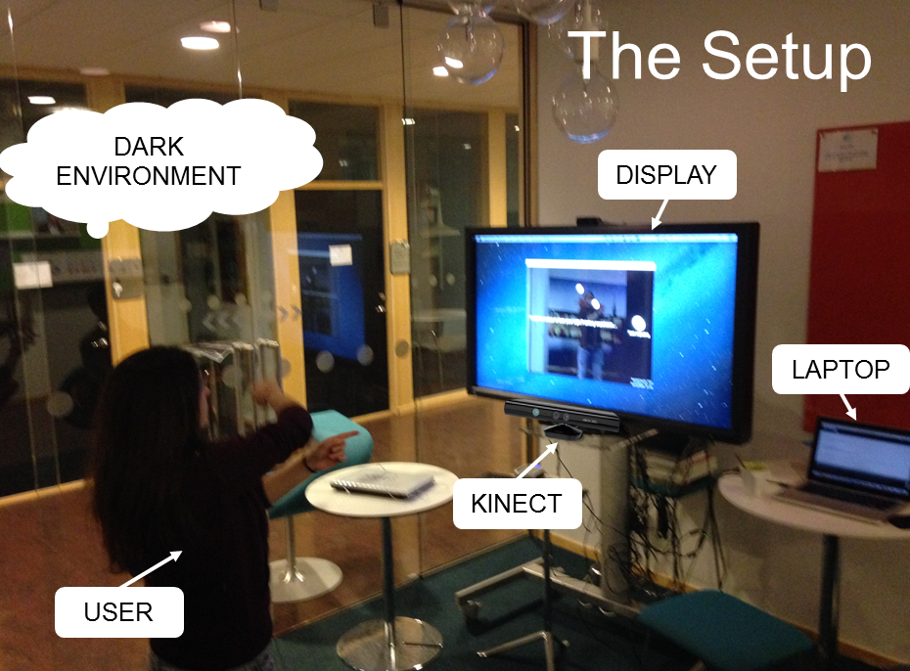

*Figure 1: Our light painting with Microsoft Kinect Setup*

A Kinect and a computer with an optional extra monitor display are the basic input and output devices for this application. As a basic set up, the Kinect is placed at the same level of the user so the hand movement of the user can be captured with ease, while the screen monitor would be placed over the Kinect at the eye-level of the user so the user can have better visual feedback.

Processing is chosen to visualise our application because it is a fast and easy-to-use illustration-based programming tool with in-built Integrated Development Environment (IDE). It is a programming language built on Java, also having its own IDE. In order to use Processing and Kinect together, the OpenNI SDK [20] appears to be a better choice because they have SimpleOpenNI [29] as a wrapping library to support using OpenNI in Processing. Also, the OpenNI SDK works well for both Windows and MacOS platforms. In order to support development collaboration, GitHub [10] was also used as a version control tool.

* OpenNI SDK (Kinect Library)
* SimpleOpenNI - A simple wrapper library of Processing for OpenNI
* Processing
* Windows/ Mac machine
* (optional) Big monitor display

## Application Specification

We developed an operational flow (as shown in Appendix A) and finally the application contained four pages (as shown in the figure 2).

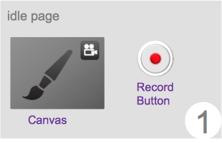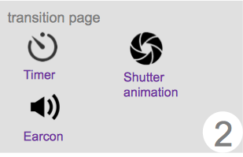

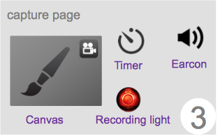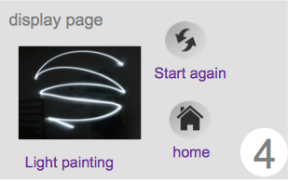

*Figure 2: 1. idle page 2. transition page 3. capture page 4. display page*

1. **Idle page**: This page is a start or home page of the application and is usually there to capture the user’s interest and prepare them to start the light painting experience using Kinect. It comprises of the canvas that detects the hand gesture, drawing light trails on top of a live video captured by the Kinect camera, without anything being recorded though. A record button is there that enables the user to go to the transition page eventually leading to the capturing page.
2. **Transition page**: This page is a transition between Idle page and Capture page to let the users get ready for the recording. It provides some visual and audio hints to give users a feeling of being photographed; these hints include a shutter animation and a shutter opening sound, a numeric count-down timer together with a synchronous timer ‘beep’ earcon.
3. **Capture page**: This page captures the users’ painting trails on the canvas and also the images from the kinect RGB camera. During the capturing time, it also gives a real-time feedback to the user by a beep earcon, a timer showing the recording time left and a red recording light that blinks continuously imitating camera recording in progress and finally a shutter close earcon, to mark the end of the capture.
4. **Display page**: This is the page where the light painting image is displayed, which is comprise of user’s painting on top of a photo captured from the user’s context. It also has two buttons to let users start the capturing again or return to home page.

# Technical Development

As mentioned in the previous section, Processing was our main development environment in which all implementation was done. In general, the concept of Model-View-Controller [9] was adopted in the program design where function modules were broken down into classes and categorised under view, controller, data structure, tools, configs, etc. For instance, defined classes can be found in the class diagram (see Figure 4) below.

CPageController is a singleton controller class which controls all page flow, i.e. jumping from one page to another. The layout and features of each page were defined in each page class, i.e. CPageIdle, CPageInitilise, CPageCapture, CPageDisplay. Some general UI components were also implemented as classes and they were used when defining the content of each page, e.g. CButton, CLabel, CSprite, etc. Other than this, CCanvas and CLightSource were also UI components contributing to the core feature of the application which is the painting feature.

Due to the fact that the Kinect device was not always available during the development process, the application was also designed to work with general mouse cursor. For this reason, there were two input controllers extending the CInputControllerBase class, i.e. CInputKinect and CInputMouse. Some other input interfaces are also possible to be added to the application by extending CInputControllerBase class in the future. In order to support multiple inputs, CInputManager was designed to be a singleton class to manage and control all the inputs, each instance of CInputKinect represents one user input, i.e. one hand, and were stored inside InputControllerMap under CInputManager.

## Working with Kinect

Kinect consists of a depth camera, which can tell the distance of the objects and people in front of it in the form of an image **[**5**]**. The very basic data that Kinect can provide is the depth image captured by its infrared camera. On top of the depth image, OpenNI has the ability to process the depth image to detect and track people for us. Therefore, we can take a more direct route by making use of this user-tracking technique to track user’s input instead of working directly on the depth image.

When it comes to user tracking, SimpleOpenNI provides a full-body skeleton tracking and also an almost-calibration-free hand tracking. Full-body skeleton tracking requires user to stand in a “submissive” pose as a calibration starting pose, while hand tracking only requires a very easy raise-hand starting pose. Considering our application, which mainly relies on user’s hand to paint, and also the hand-tracking technique is almost calibration-free, i.e. only requires a very natural raise-hand starting pose, and hence allows users to get started much faster and more naturally, hand-tracking technique was chosen over full-body skeleton tracking in our application.

Several callbacks regarding the use of hand-tracking provide by SimpleOpenNI, namely OnNewHand(), OnTrackedHand(), OnLostHand() and OnCompletedGesture(), were implemented in CInputManager (see CInputManager in Figure 4). Every time a new hand is detected, i.e. OnNewHand event, this hand input would be registered in CInputManager and the position coordinates would be updated when OnTrackedHand() is called, and vice versa, the hand input would be deregistered when the hand input is lost, i.e. OnLostHand() called. The location coordinates given by Kinect are coordinates in real-world 3D-space. In order to display this on the 2D-plane in our application, a conversion from real-world 3D coordinates to projected 2D plane has to be done (see Figure 3) by calling a function, convertRealWorldToProjective(), provided by SimpleOpenNI.

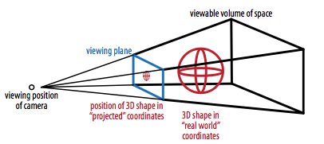

*Figure 3: Real-world 3D coordinates to projective 2D plane*

Differentiated from a normal brush in a canvas, the light source also possesses time-related characteristics, i.e.. the length of the succeeding trails and the thickness of the trails. Therefore, instead of only storing location-based information in CInputManager.InputControllerMap using the default PVector datatype, a new datatype of TimePVector was introduced to also store the required time information, specifically TimePVector inherits PVector with extra timestamp information.

In order to implement the extra feature of “supporting drawing on photo”, the RGB camera of Kinect was also enabled together with the IR camera. Therefore, user can see the live view of himself/herself in their context, while playing around on the canvas, and this RGB image would be captured together with the painting image and both would be shown together in the final display page, i.e. CPageDisplay. However, this photo capture feature was not implemented for non-Kinect input because this application was designed to work with Kinect mainly and the mouse cursor input only serves as a work-around for aiding the development process.

There are also some third-party libraries in Processing which are readily to be used. In the application, we made use of an audio library, namely “minim”, that could playback various audio files through its in-built audio player. The functions in this library were used for generating audio feedbacks in the application.

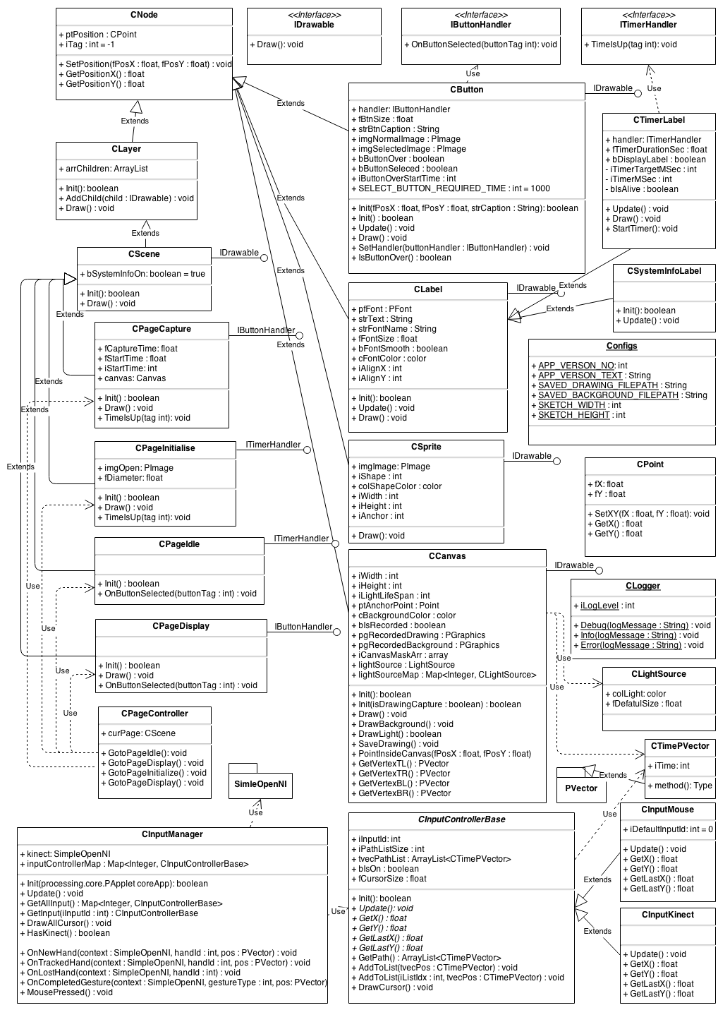

*Figure 4: UML Class diagram*

# Evaluation

The experiment was held at EIT ICT Stockholm Co-location Center, a comfortable place for students to study, in order to give the participants a familiar and casual environment [25].

A *qualitative evaluation method* [4] was selected, because the purpose was to collect data that represent the behaviour, personal satisfaction and opinions of the users while interaction, as well as comments and suggestions for improvement. Due to the early stage of our development process, an *exploratory study* [26] was conducted, using *participant observation* [16] in combination with *interview* [16] techniques. Given the nature of the application and the time that was planned to dedicate on it, three rounds of testing seemed a satisfactory number for receiving valuable feedback. The first two user testings took place with one participant at a time, while the last one with two participants simultaneously, in order to examine the efficiency of the multi-user interaction with the application.

Collecting personal information did not serve any purpose in the evaluation, neither did recording the session, as there were already two people taking notes, therefore no written consent forms were needed. As a lot of people are not familiar with the nature of light painting, we explained the participants about the technique, before the experiment, and provided a video [12] to give a clearer image, as we would ask them how close the resemblance of the application would be with the actual result.

Due to our strict time-schedule, we invited four of our fellow co-students as participants. The initial belief that our existing relationship would encourage them to express themselves freely and truthfully was strengthened by their eagerness to spend more time with the application and giving more suggestions as so. Additionally, it enabled us to interpret more accurately their expressions and comments.

During the test, two of the team members were observing the participant and taking notes, following the method of *shadowed observation* [1], where the participant is aware that is being observed and had consented to it. The facilitator was introducing the user to the environment and the setup, and would ask them to *think-aloud* [1] while interacting with the implementation. At key points, the facilitator would also ask questions to the participant, following an *unstructured interview* [1**]**, in order to get impressions and feelings from the interaction. The interview was originally planned to be held only after the interaction, but for many participants it was necessary to go back to the application in order to explain us what they were saying. For this reason, we adopted the method also during the interaction. After each testing the roles of the evaluators would rotate [26] and when the evaluation was over, the data analysis was made by triangulating [25] of the collected data.

The results that came up from the evaluation were quite interesting and gave substantial insight to the interface implementation. Originally, the participants were confused on how to start the application, as it was not clear that in order to start capturing they were supposed to ‘press’ the “start” button. The initial page that illustrated the canvas was aiming to attract the user’s attention, but it was instead misleading them to think that every move was being captured. The fact that the original icon, which illustrated a camera lens, did not resemble a button did not help. Quoting some of the users: *“I thought it was a logo, didn’t know it could be pressed”*. Second, the black space that signed the end of the canvas, was acting as a constraining factor to the users who thought that *“that area was off limits”*,therefore they would not go so far as to press the button. However, we consider that to be an advantage of our implementation, as by making use of the power of constraints [3], the user is discouraged to draw outside the capture area.

A desired effect of the project was to create a HiFi soundscape that would both imitate real-time photography and inform the user of what is happening on each screen. From users’ testimonies, it is safe to say that we have successfully fulfilled that goal, as they mentioned that the earcons resembled camera sounds. Other suggestions that were adopted in the next version of the application, were the resizing of the labels, especially the timer’s. Although a corresponding earcon was provided to prompt the user of the time constraints of the photo capture, seeing the seconds left was aiding them significantly and asked to enlarge the indication.

Further comments that will be considered in future work concern adjusting the settings of the capture. Some users asked for more time to finish the drawing, while one asked to be able to stop when he wishes to, or to set the timer on his own.

The overall experience was actually a lot of fun and the users seemed to want to play more and more. Some users reported that it is *“unpredictable, because you can’t see what is being drawn, it’s fun”* and even one user that had previous knowledge of light painting techniques was surprised by the resemblance of the effect to real photography.

Consequently, the changes made after the evaluation was to change the layout of the first screen, by replacing the initial icon with a button and highlight it on selection, and adding a message instructing the user to press it in order to start capturing. The timer was also enlarged on the capture screen. Due to limited time, a second evaluation was not conducted, as the team preferred to spend more time on adding extra features and enhancing the interface. Indeed, a real-time camera capture is now available in our application.

# Final Version

The application is the major deliverable of this project, where the program source can be found on github, at <https://github.com/arindrakumardas/kinectlightpainting>. Some screen capture of the application are also shown in Figure 5 below. Also, a demo video can be seen at <http://vimeo.com/84351535> .

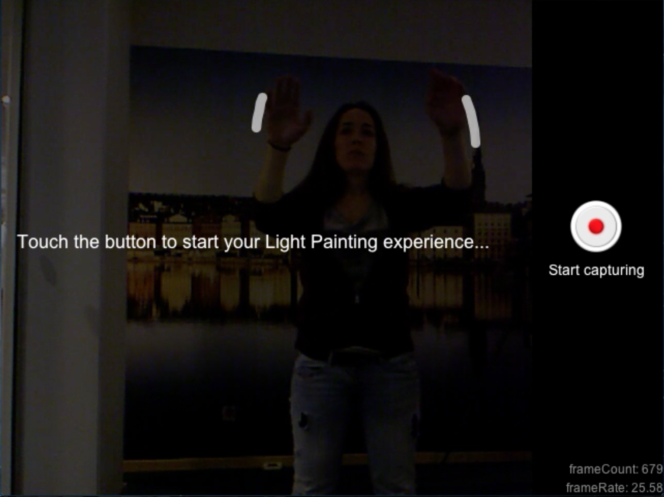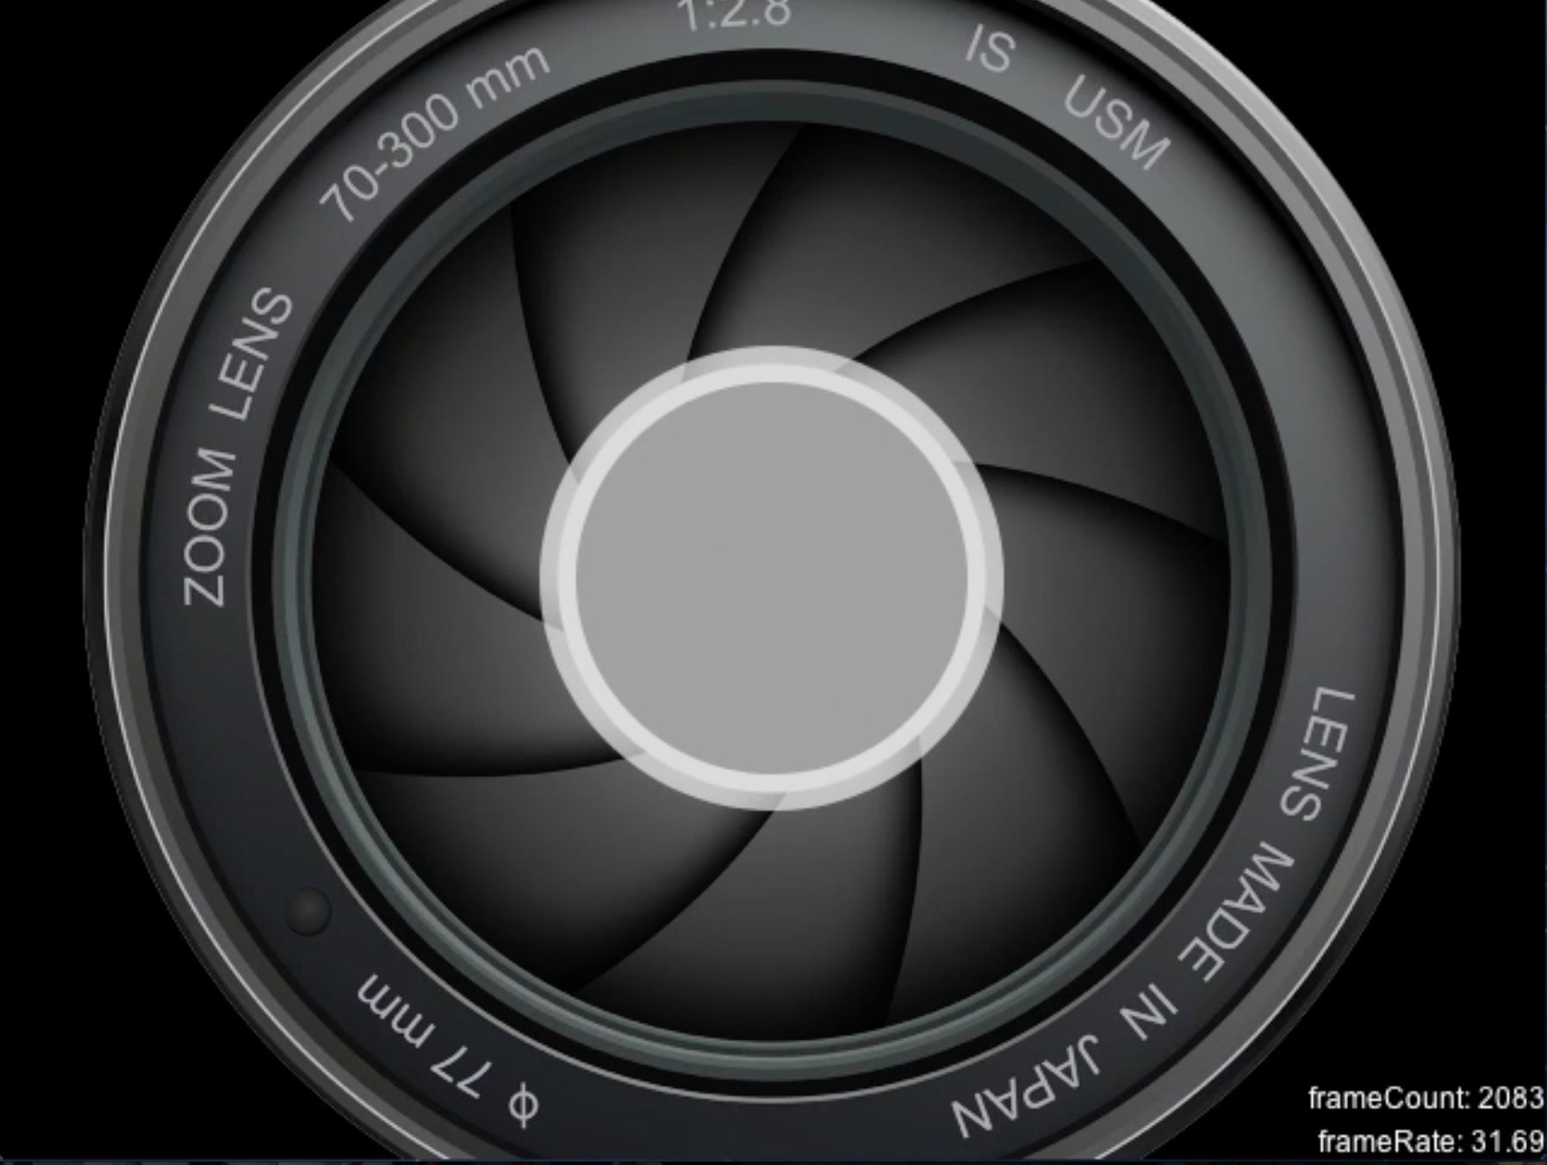

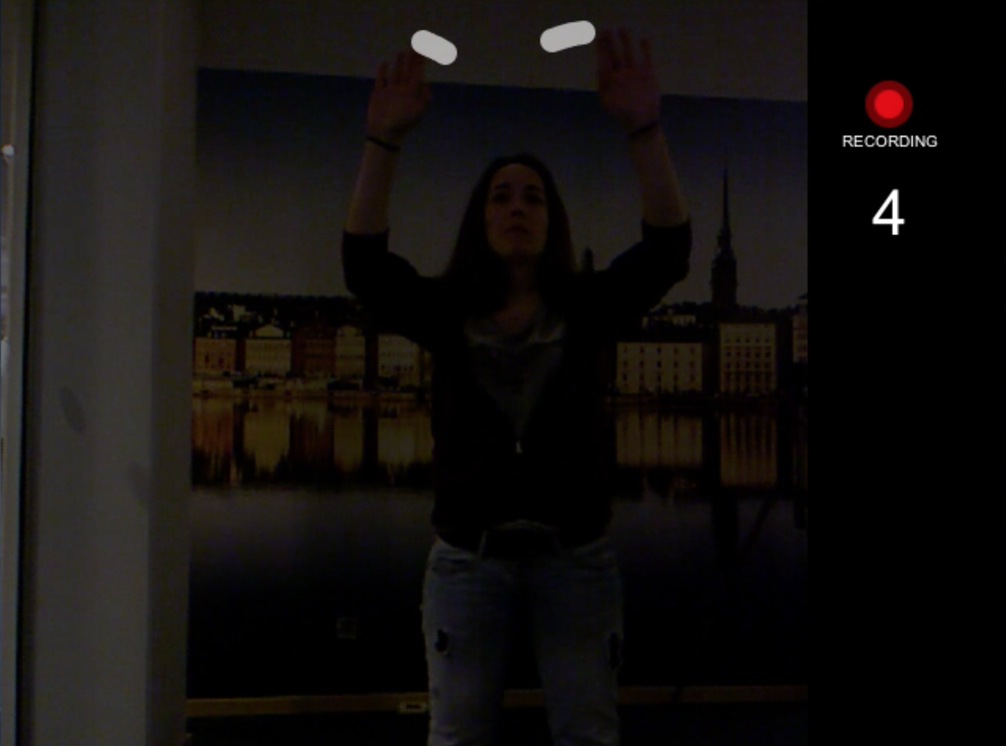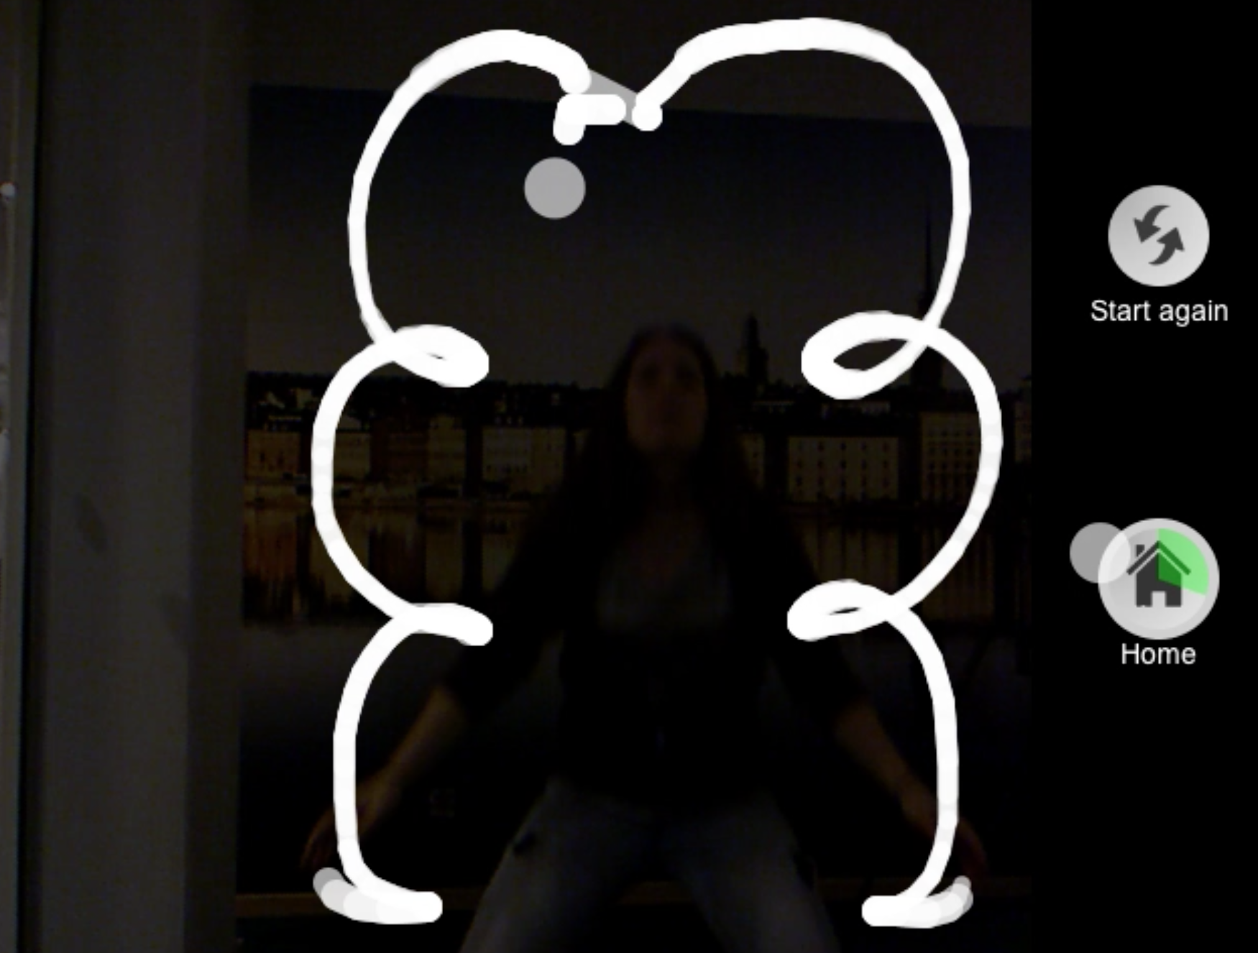

*Figure 5: the screenshots from our application   
(top-left: Idle page, top-right: Transition page, bottom-left: Capture page, bottom-right: Display page)*

# 

# Conclusion

Replicating the experience of light painting in Kinect indicates the creation of art usually done through traditional cameras.

In order to have the same experience of light painting done with the traditional camera, we added features such as animation for shutter opening and earcons. In fact, during the user evaluation, we got positive response that these effects did help them to relate to the traditional light painting. Also, allowing the users to see their cursor positions while drawing proved to be a plus point as one of the participants commented that he liked experience of drawing as he could see in which way he was drawing, which is not possible in traditional light painting.

However, our application can be further improved by simulating a light source more closely to that of a real one. Also, our application can be made better by providing options to adjust the settings, such as incorporating more than one light source, with different colours and providing adjustable exposure time. The graphics can be made more advanced by making the drawing three-dimensional. The user-experience can be enhanced if the users are given an option to save their drawings and share them with their friends. Similarly, they can be given the flexibility to build on the existing drawing or start a new one. Also, more features of Kinect can be exploited by having more modalities for interaction, such as speech recognition, for better and easy control of the application. We observed that the Kinect sometimes doesn’t detect hand movement when the users create their light painting, so better calibration techniques are needed before use. It is also possible that this is an inherent problem of Kinect, so either a newer version needs to be used or we may have to modify our application based on this limitation.

This project provided us a fantastic opportunity to learn about a technology, i.e. Kinect, that is rapidly gaining popularity [21]. While making the application, we realized that this technology, a motion sensing device, has a huge potential for revolutionizing many areas in human-computer interaction. Most importantly, we have got an essence of how art is done in the digital world.

Regarding the dynamics of our team, it is very interesting to note the synergy that was there among us while working for this project. Throughout the process, since the numerous brainstorming sessions to the final project deliverables, our team has been consistently working by splitting all the tasks equally on every step. Everyone has taken different responsibilities related to the application development, e.g. program framework and design, input controls, UI layout and flow implementation, look and feel, sound implementation, painting effect on canvas, etc. According to the project proposal, most of the extended features, except the feature about advanced controls settings in phase 2.0, were all well implemented in our application which can be seen in our final deliverable (see Project plan in Appendix B). It is good to see that our project proposal was well fulfilled.

Summing up, after extensive consideration on the subject, we created an application using Kinect which closely resembles the light painting technique of traditional photography. During this process, we learnt about working with the Kinect and also about integrating our code with its possibilities. Then based on the comments and feedback of participants during user evaluation, we modified the look and feel of our application so that it is more user-friendly. And thus, we finalized our application on light painting using kinect.

# 

# References

[1] M. Aasbacken , 2011. *Evaluating User Experiences from Interactive Art Installations.* Unpublished specialization project, Norwegian University of Science and Technology, Oslo.

[2] A Beginner’s Guide to Home Photography [Online]. Available: <http://www.homephotog.com/tutorials/shutter-speed.shtml>. [Accessed: 19-Jan-2014].

[3] D. Benyon, *Designing Interactive Systems: A comprehensive guide to HCI and interaction design.* Pearson Education Limited, 2nd Ed, 2010.

[4] B. Berg, 2001. *Qualitative Research Methods for the Social Sciences.* Allyn and Bacon, 4th Ed.

[5] G. Borenstein, *Making Things See: 3D Vision with Kinect, Processing, Arduino, and MakerBot*. O’Reilly Media, Inc., 2012.

[6] S. Crawford, “HowStuffWorks ‘The Kinect Sensor ’,” *HowStuffWorks*, 13-Jul-2010. [Online]. Available: http://electronics.howstuffworks.com/microsoft-kinect.htm. [Accessed: 19-Jan-2014].

[7] R. Doble, *Experimental Digital Photography*, 1st ed. Lark Books/Sterling Publishing, New York/London, 2010.

[8] B. Dumas, D. Lalanne, and S. Oviatt, “Multimodal Interfaces: A Survey of Principles, Models and Frameworks,” in *Human Machine Interaction*, D. Lalanne and J. Kohlas, Eds. Springer Berlin Heidelberg, 2009, pp. 3–26.

[9] M. Fowler, GUI Architectures [Online]. Available: <http://martinfowler.com/eaaDev/uiArchs.html>. [Accessed: 19-Jan-2014].

[10] “GitHub.” [Online]. Available: https://github.com/. [Accessed: 19-Jan-2014].

[11] J. Golbeck, Direct Manipulation, 2002 [Online]. Available: <http://www.cs.umd.edu/class/fall2002/cmsc838s/tichi/dirman.html>. [Accessed: 19-Jan-2014].

[12] How To: Light Photography/Painting 101 [Online]. Available: <http://www.youtube.com/watch?v=WqEIikVSxVA>. [Accessed: 19-Jan-2014].

[13] D. F. Keefe, D. A. Feliz, T. Moscovich, D. H. Laidlaw, and J. J. LaViola,Jr., “CavePainting: A Fully Immersive 3D Artistic Medium and Interactive Experience,” in *Proceedings of the 2001 Symposium on Interactive 3D Graphics*, New York, NY, USA, 2001, pp. 85–93.

[14] Kinect for Windows, Microsoft Corporation, 2012 [Online]. Available: <http://www.microsoft.com/en-us/kinectforwindows/>. [Accessed: 19-Jan-2014].

[15] Light Painting Kinect, 2013 [Online]. Available: <http://www.microsoft.com/en-us/kinectforwindows/>. [Accessed: 19-Jan-2014].

[16] N. Mack, K. M. MacQueen, G. Guest, & E. Namey, *“Qualitative Research Methods: A Data Collector’s Field Guide”*. Family Health International, 2005. Available: http://www.fhi360.org/resource/qualitative-research-methods-data-collectors-field-guide. [Accessed: 19-Jan-2014].

[17] J. Moeller, N. Lupfer, B. Hamilton, H. Lin, and A. Kerne, “intangibleCanvas: Free-air Finger Painting on a Projected Canvas,” in *CHI ’11 Extended Abstracts on Human Factors in Computing Systems*, New York, NY, USA, 2011, pp. 1615–1620.

[18] W. Mäkelä, M. Reunanen, and T. Takala, “Possibilities and Limitations of Immersive Free-hand Expression: A Case Study with Professional Artists,” in *Proceedings of the 12th Annual ACM International Conference on Multimedia*, New York, NY, USA, 2004, pp. 504–507.

[19] J.C. Naour, Kinect Graffiti™, 2011 [Online]. Available:<http://jcnaour.com/#Kinect-Graffiti->. [Accessed: 19-Jan-2014].

[20] OpenNI: Standard framework for 3D sensing, OpenNI Org*.*, 2010 [Online]. Available: <http://www.openni.org/>. [Accessed: 19-Jan-2014].

[21] “Popular Science Honors Kinect for Xbox One with 2013 “Best of What’s New” Award”, 2013 [Online]. Available:<http://news.xbox.com/2013/11/xbox-one-popular-science-award>. [Accessed: 19-Jan-2014].

[22] Processing, 2013 [Online]. Available: <http://www.processing.org/>. [Accessed: 19-Jan-2014].

[23] L. M. Reeves, J. Lai, J. A. Larson, S. Oviatt, T. S. Balaji, S. Buisine, P. Collings, P. Cohen, B. Kraal, J.-C. Martin, M. McTear, T. Raman, K. M. Stanney, H. Su, and Q. Y. Wang, “Guidelines for Multimodal User Interface Design,” *Commun. ACM*, vol. 47, no. 1, pp. 57–59, Jan. 2004.

[24] D. Rocchesso and R. Bresin, “Emerging Sounds for Disappearing Computers,” in *The Disappearing Computer*, N. Streitz, A. Kameas, and I. Mavrommati, Eds. Springer Berlin Heidelberg, 2007, pp. 233–254.

[25] Y. Roggers, H. Sharp and J. Preece, *Interaction Design: Beyond Human-Computer Interaction*, Wiley Publishing Inc., 3rd ed., 2011.

[26] J. Rubin and D. Chisnell, *Handbook of Usability Testing: Howto Plan, Design, and Conduct Effective Tests*. John Wiley & Sons, 2008.

[27] R. M. Schafer, *The Tuning of the World*. McClelland and Stewart Limited, Toronto, 1977.

[28] J. Scheible and T. Ojala, “MobiSpray: Mobile Phone as Virtual Spray Can for Painting BIG Anytime Anywhere on Anything,” *Leonardo*, vol. 42, no. 4, pp. 332–341, Aug. 2009.

[29] SimpleOpenNI, OpenNI Library for Processing, 2013 [Online]. Available: <http://www.openni.org/files/simpleopenni/>. [Accessed: 19-Jan-2014].

[30] Z. Zafrulla, H. Brashear, T. Starner, H. Hamilton, and P. Presti, “American Sign Language Recognition with the Kinect,” in *Proceedings of the 13th International Conference on Multimodal Interfaces*, New York, NY, USA, 2011, pp. 279–286.

# 

# 

# Appendix

## Appendix A: Operational flow diagram

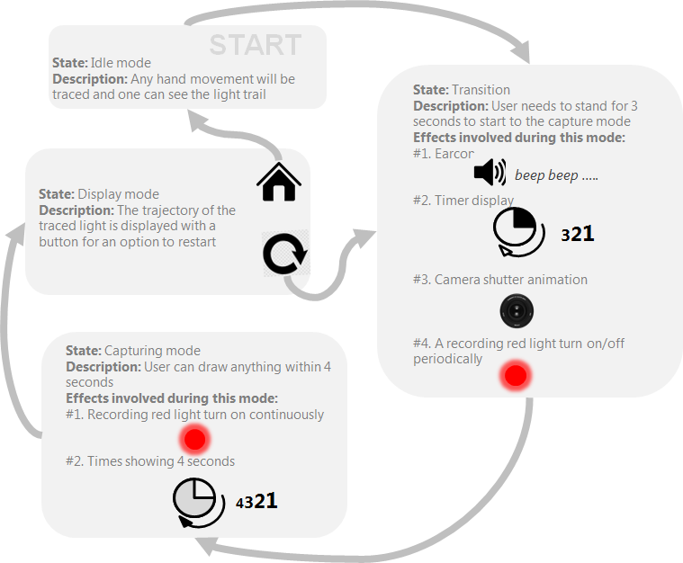

*Figure a: Flowchart operational diagram*

## 

## 

## 

## 

## 

## Appendix B: Project Plan from Project Proposal

The project will be broken down into the following phases, and implemented one by one. Each phase has a defined milestone to meet. Any phases and milestone starting with phase 2.0 will be regarded as extended or future work of this project and will be done if time allows, while anything before that will be considered as basic required deliverables for this project.

|  |  |  |
| --- | --- | --- |
| **Phase** | **Tasks Description** | **Milestone** |
| 0.0 | Pre-study and research | N/A |
| 1.0 | Set up development environment | Run a HelloWorld project with Kinect |
| 1.1 | - Define program structure and classes - Implement basic classes  - Collaborate them | Capture Mode : a drawable canvas with fading light trails and recorded drawings |
| 1.2 | Implement other controls and modes (Idle Mode, Display Mode and controls between) | A workable application with complete flow as defined (from Idle, to Capture and Display Modes) |
| 1.3 | Evaluate and refine version from phase 1.2 | A complete launchable application (with all sounds feedback, visual effect and aesthetic concerns taken) |
| 2.0 | Implement advanced controls (a settings menu for customizing timer, light sources, color, etc) | A complete application with settings for customizing timer, light sources, color, etc |
| 2.1 | Support more than 1 human control (more than 1 light sources drawing simultaneously) | More than 1 light source is supported |
| 2.2 | Support drawing on photo taken by Kinect camera | Kinect camera can take photo and user can do painting on it |

## Appendix C: Project Plan Timeline

